Holy Angels Mission, Angel Fire, NM

Regular Mass Schedule
Church LOCATION: 34 Westridge Road, Angel Fire, NM (South on 434, turn right at "Elliott Barker Girl Scout" sign. Church is on the right side of road.
​Mass Time:
12:00 noon Tuesday and Thursday
8:00 am on Saturday (does not count for Sunday)
5:30 pm on Saturdays
8:00 am Sunday
Confession:
Ten minutes before mass or after mass).
​
Click Below to Download the Latest Parish Bulletin and Ministry Schedule
holy_angels_ministry_schedule_sunday_may_june_2019.doc  Download File  holy_angels_ministry_schedule_saturday_may_june_2019.doc  Download File | bulletin_june_9_2019_st._joseph___immaculate_conception_-_springer_nm___parishes_online.html  Download File

Our Pastor Father Trieu
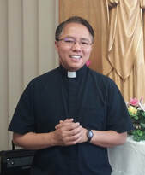
On June 17, 2017 we welcomed our new Pastor, ​FR. BENOIT TRIEU VAN VU. He serves as the Pastor for Immaculate Conception and its Missions!
Father Benoit Trieu Van Vu (Trieu pronounced like "Cheu")
Following is a note Father Trieu wrote telling us a little about himself:
"My name is Benoit Trieu Van Vu. I like to be called Fr. Trieu (pronounced "Chu"). I was born in Vietnam in a fervent Catholic family of seven children. I am the baby. My home parish’s name is Yen Tho. It belongs to the Diocese of Phat Diem where the Catholics are very devout and traditional. My Diocese is well known by the oriental architecture of its cathedral.
I have desired to be a priest since when I was around 10 years old. Vietnamese Catholic Church in the 1980s, especially the Church in the north had met a lot of difficulties. However, we, little boys, kept practicing our Catholic faith faithfully and joyfully. We, every day, went to our parish church for evening prayer, even though, at that time, our church did not have the Blessed Sacrament, because we did not have a pastor. The lack of a pastor and the sacraments raised within me a desire to become a priest.
When I was 22 years old, I entered a Benedictine Monastery in Saigon, but always sensed there was something more. When I was 37 years old, I went to Mt. Angel Abbey in Oregon to study scripture. Through the help of Christ in the Desert Monastery, I was led to the Archdiocese of Sana Fe Vocations Office to finish my studies and become a priest. In June 2014, I was ordained deaconate and served at St. Charles Borromeo for one year. I was ordained a priest on May 23, 2015. I was then assigned as the Parochial Vicar at Our Lady of Sorrows Parish in Bernalillo, NM. I was appointed Pastor of St. Joseph's, Springer and Immaculate Conception, Cimarron & missions on June 17, 2017.

Father Doug Mitchell Now in Angel Fire
Great news! Father Doug Mitchell recently retired from Our Lady of Sorrows in Las Vegas, NM. He owns a home in Angel Fire and has decided to help Father Trieu by giving mass on Tuesdays and Thursday at noon and also on Saturday and Sunday mornings at 8:00 am. The 5:30 pm mass on Saturday with Father Trieu will continue. So now we have almost daily mass!!
On-line Donations:  Consider setting up a weekly or monthly automatic donation on-line. To set it up, just go to:  https://tinyurl.com/OLG-ICC | Donate On-Line Safely and Easily  For your information, Congress has PERMANENTLY restored the IRA gift option for donors age 70 ½ and over. This is a simple way to make a charitable gift by using funds from your IRA. Plus, the transfer will count towards your annual required minimum distribution.  You may transfer up to $100,000 from your IRA to charities without the transfer being counted as taxable income.  Holy Angels Mission will be more than happy to help you reduce your income tax if you wish to take advantage of this provision!  To purchase tickets to events on-line, you may use http://www.wepay.com/donate/18179 which also provides a secure and safe way to purchase tickets. (This method should be used strictly for purchasing tickets since there is a small fee to the church.)

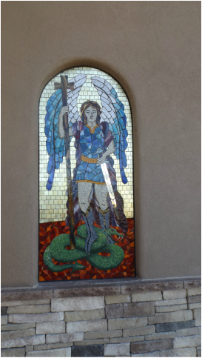
This mosaic of St. Michael the Archangel now graces the front of the church. It's one of the first things you see when you drive up to the church. It is absolutely beautiful. The artist, Kyle Erickson, is from Albuquerque. His work is beautiful we are so blessed that he produced such a beautiful piece of art for our church. It sends a message immediately that we ARE the Holy Angels!

Our Mission is Dedicated!
On December 20, 2014, at 5:30 mass, Archbishop Sheehan dedicated our Mission Church, Holy Angels. It was a blessed and wonderful day. Thank you to so many of you that have made it possible. Although we have built our church, we will continue to fund raise to pay the mortgage. We will let you know what the amount is once everything is cleared with the Archdiocese. This website will change from a construction progress website to a church website. The changes will occur as we realize the needs of the church. Although we have our own building now, we are a Mission of Immaculate Conception in Cimarron, so if you need any help with baptisms, weddings, etc, please contact Immaculate Conception to make the arrangements.

THE HOLY ANGELS
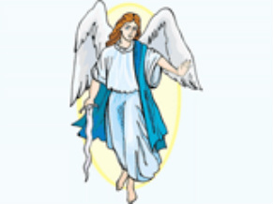
Make yourself familiar with the angels, and behold them frequently in spirit; for without being seen, they are present with you."

